

#### **Assignment Cover Sheet**

|  |  |  |  |  |  |  |  |
| --- | --- | --- | --- | --- | --- | --- | --- |
| **Student name’s:** | **Cian Butler, Stephen Cagney, Tony Divilly, Miguel Rey** | | | | | | |
| **Student number:** | **2883486 - 2887147 - 2882360 - 2875163** | | | |  | | | |
| **Faculty:** | **Computing Science** | | |  | | | |
| **Course:** | **BSCH-SWD/Dub/PT** | | | **Stage/year:** | | **2** | |
| **Subject:** | **Server Side Web Development** | | | | | | |
| **Study Mode:** | Full time |  |  | Part-time | | **X** |  |
| **Lecturer Name:** | **Aqeel Kazmi** | | | | | | |
| **Assignment Title:** | **SSWD – Group Project** | | | | | | |
| **No. of pages:** |  | | |  | | | |
| **Disk included?** | Yes |  |  | No | | **X** |  |
| **Additional Information:** | (ie. number of pieces submitted, size of assignment, A2, A3 etc) | | | | | | |
|  | | | | | | |
|  | | | | | | |
| Date due: | **25/03/2016** | | |  | | | |
| Date submitted: | **25/03/2016** | | |  | | | |
|  | | | | | | | |
| **Plagiarism disclaimer:**  *I understand that plagiarism is a serious offence and have read and understood the college policy on plagiarism. I also understand that I may receive a mark of zero if I have not identified and properly attributed sources which have been used, referred to, or have in any way influenced the preparation of this assignment, or if I have knowingly allowed others to plagiarise my work in this way.*  *I hereby certify that this assignment is my own work, based on my personal study and/or research, and that I have acknowledged all material and sources used in its preparation. I also certify that the assignment has not previously been submitted for assessment and that I have not copied in part or whole or otherwise plagiarised the work of anyone else, including other students.*  **Signed: Cian Butler, Stephen Cagney, Tony Divilly, Jose Miguel Rey Date: 25 Mar 2016_______** | | | | | | | |

## **Please note:** Students **MUST** retain a hard / soft copy of **ALL** assignments as well as a receipt issued and signed by a member of Faculty as proof of submission.

Table of Contents

Summary: 3

Wireframe: 4

Functionality: 7

Registration/login: 7

Member Ship Level: 7

Account Management: 8

Membership Area: 8

Subscribe: 8

Create Class: 8

Calendar of Classes: 8

Class review: 8

Newsletter: 9

Site Map: 9

ERD and relationship schema: 10

Attributes 10

Relationships and Multiplicity 11

ER Diagram 12

# Summary:

This website forms part of the continuous assessment for the server side web development module. The website will be based on a fitness centre, the users will be able to navigate the site and information. They will also be able to request information about classes, prices and sign up to the fitness centre. When users sign up there information will added directly into the database. This database will be password protected for staff only. In the administration section staff will be able to:

* Log in
* Add new members to the database
* Edit/delete/search for users
* Edit/delete/search for information about classes and prices on the html pages

This document will contain:

* A wireframe, this is used to show the proposed layout, design and structure of the website
* The functionality of the website, this is used to describe how the website will function i.e. show how it will interact with the database and how each page is linked together.
* The database design, this will include an ERD (entity relationship model) and the relationship between each table within the database.

# Wireframe:

|  |  |
| --- | --- |
| Desktop wire frame | Mobile wire frame |
| E:\Users\Stephen\Dropbox\Dropbox\AwesomeCyborgs\Wireframes\desktopWireframeHome.png | C:\Users\Stephen\Documents\GitHub\AwesomeCyborgs\wireframe\mobileWireframeIndex.png |
| C:\Users\Stephen\Documents\GitHub\AwesomeCyborgs\wireframe\desktopWireframeMembership.png | C:\Users\Stephen\Documents\GitHub\AwesomeCyborgs\wireframe\mobileWireframeMembership.png |
| C:\Users\Stephen\Documents\GitHub\AwesomeCyborgs\wireframe\desktopWireframeClasses.png | C:\Users\Stephen\Documents\GitHub\AwesomeCyborgs\wireframe\mobileWireframeClasses.png |
| C:\Users\Stephen\Documents\GitHub\AwesomeCyborgs\wireframe\desktopWireframeFeedback.png | C:\Users\Stephen\Documents\GitHub\AwesomeCyborgs\wireframe\mobileWireframeFeedback.png |
| C:\Users\Stephen\Documents\GitHub\AwesomeCyborgs\wireframe\desktopWireframeAboutUs.png | C:\Users\Stephen\Documents\GitHub\AwesomeCyborgs\wireframe\mobileWireframeAboutUsxml.png |
| C:\Users\Stephen\Documents\GitHub\AwesomeCyborgs\wireframe\desktopWireframeAdmin.png | C:\Users\Stephen\Documents\GitHub\AwesomeCyborgs\wireframe\mobileWireframeMembership.png |

# Functionality:

We plan on implementing various features that allow our clients to take full advantage of offers available.

Features that will be implemented as follows:

* Registration/Login
* Member Area
* Member Ship Level
* Account Management
* Subscribe
* Create Class
* Calendar of Classes
* Class review
* Newsletter

### Registration/login:

Member will able to create an account on our servers for additional features that will be unavailable for non-members, such as the member’s area, users will be able to create a new account with the username of their choice. During registration users will also be able to sign up for our newsletter, Registration is complete user will then be able to log in.

### Member Ship Level:

Member Ship Level will be an option selectable upon registration and each level will have more access areas of the website. The following membership options will be:

* Free Membership: This option will be the most basic option allowing people to see what classes are available and make bookings for each class, as well as read any reviews available.
* Gold Membership: This option will allow for use of the subscribe feature, access to a forum and will allow users to create reviews with a rating of classes they attended.
* Platinum Membership: This will give users access to all the features and classes that the fitness centre have to offer.

### Account Management:

The administrator will be able to manage new users on the database, edit classes and view all information about classes that users will be attending.

### Membership Area:

The member ship area will allow, upon completion of registration, will allow users to make booking for classes, create reviews on classes attended, create and comment on forums or (Depending on their membership level) be able to host classes.

### Subscribe:

This feature allows members (Gold Level+) to follow a particular class or trainer and will notify the member to any classes that will be hosted, members will also be able to unsubscribe to a class upon which they will be prompted to fill out an option survey on why they are unsubscribing.

### Create Class:

With this option members (Platinum Level) will be able to create classes and advertise the location of this class, after the creation of the class this users will also have access to information regarding attendance from other users. After a class is created, the database will mark this the date on our sites calendar, one requirement of creating a class will be that the class must contain at least one tag that summarises their class, if a classes tag is considered inaccurate Gold Level members+ may request the tag be removed.

### Calendar of Classes:

Users will have access to a calendar that will be updated by other members on classes that will be hosted on any particular date. The calendar will link users to the page displaying more information regarding classes on that day.

### Class review:

Gold users will have access to a review section that they can post up their experience with a class as well as a rating on the class attended, reviews will be only be available to be posted after the class has finished.

### Newsletter:

While registering, users have the option to subscribe to our newsletter that will notify them via email on any new classes starting up that they may be interested in joining, after selecting these option the user will be redirected to their account management page were they flag certain Class tags that ensures that the user will be informed of classes that they may be interested in.

# Site Map:

C:\Users\Stephen\Documents\GitHub\AwesomeCyborgs\siteMap\siteMap.png

# ERD and relationship schema:

### Attributes

* Staff (Staff ID, Name, Email, Phone, Address, Position, Salary, Hired Date, Date of Birth)
* Admin (Staff ID, Username, Password)
* MembershipType (Membership Type ID, Name, Description, Price, Level Number)
* Level (Level Number)
* Benefit (Benenefit ID, Name, Level Number)
* Member (Member ID, Name, Joined Date, Email, Phone, Membership Type ID)
* Room (Room ID, Name, Location)
* One activity has many classes
* Activity (Activity ID, Name, Description)
* Class (Activity ID, Time, Room ID, Staff ID)
* ClassBooking (Booking ID, Class ID, Member ID, Book Time)

### Relationships and Multiplicity

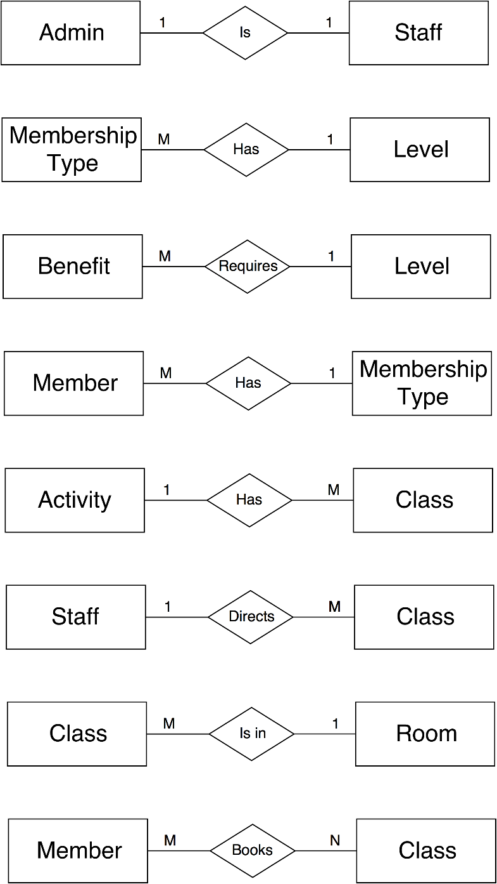

### ER Diagram

